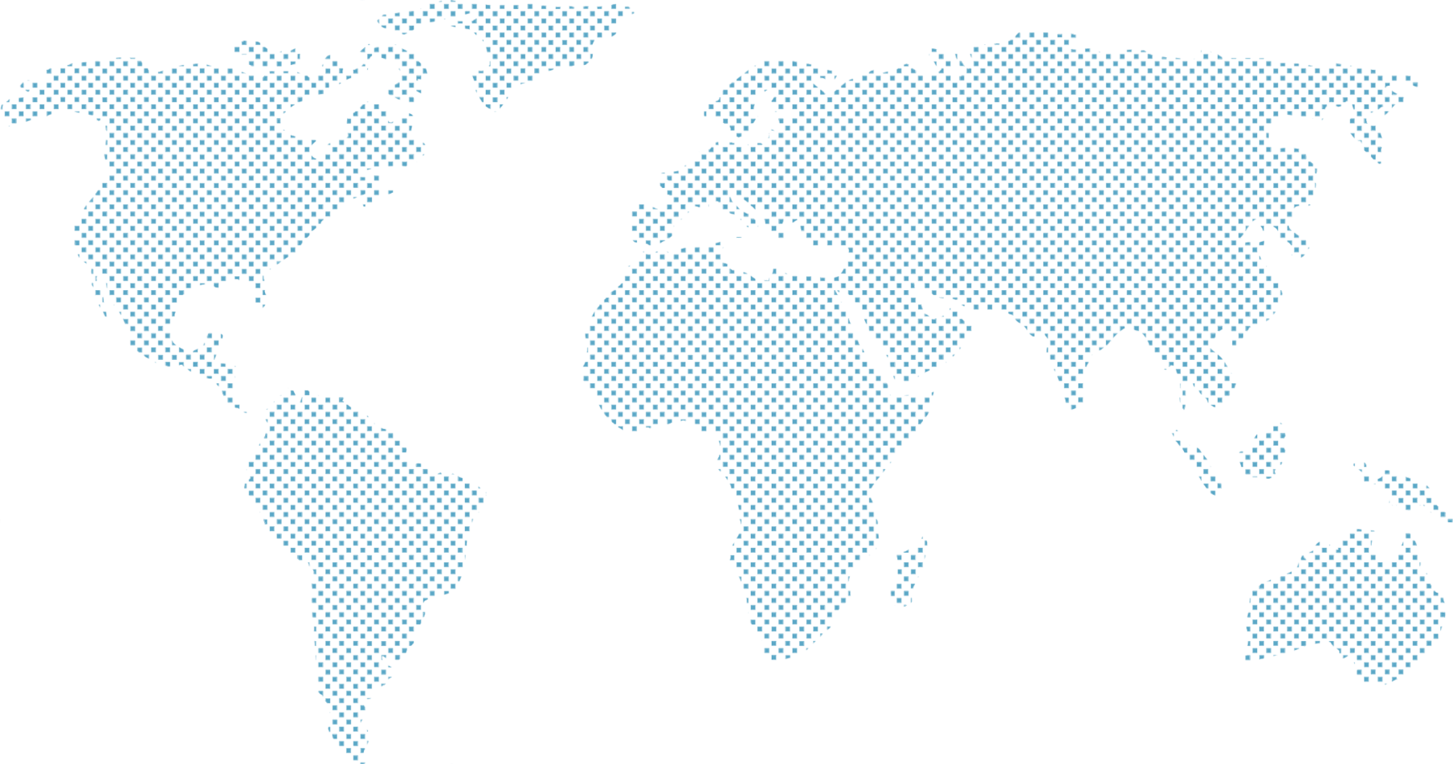

### World Wine Web

### **september 18, 2020**

***project three***

Group Four – Hannah Lee, Diego Gonzalez and Rick Gentile

September 19, 2020

##### [Click here to enter a date]

**Proposal: Wine Review**

Topic: An interactive presentation based on reviews from tasters for visitors to select wines by country, province, variety and winery.

Dataset: Beginning Dataset is from Kaggle listing the content of the above wine reviews. Meeting the requirement of at least 100 records.

**Page 1**

Inspiration: To offer visitors a method to determine countries, regions, wineries and the reviews of their selected wines. This can assist in the visitors purchase and travel destinations.

Visuals: Dashboard Page will allow the visitor to select a wine variety to compare the taste testers reviews, selection of provinces to determine the available wines and their ratings. [rgentile notes-additional categories can be discussed]

**‘Wine-ing’ Your Way ‘Round the World – An Interactive Journey to finding the Very Best Wines**

From their locations on places such as the rolling hills of Tuscany to Napa Valley which has a sign by Robert Louis Stevenson claiming ‘wine is bottled poetry’, vineyards across the world ply their art in trying to craft fine wines every year. Some of the wines are good, some great while a select few gain the status of a true classic drank by some, revered by all.

How can anyone begin to select the very finest of wines with so many to choose from?

Will this require oenophiles and casual drinkers to travel the world at great expense to enjoy the very finest wines?

Is there a method to rate the outstanding wines, identify their birthplace country and winery responsible for a wine to select for a dinner with family, a gift for a friend or just a title to try based on being mentioned by a colleague?

We believe we have the website to delight the most impeccable wine connoisseurs in helping them become more knowledgeable and to find the wines that best fit their tastes.

Based on the One Hundred Point Wine Review Scale we have examined the data and determined wines with at least a rating of 90 are worthy to make our list to be presented to wine connoisseurs everywhere. We identify the nation of origin, the winery that gave birth to the wine along with the different variety of wines all with, of course, their wine point ratings and price.

We peered into a ‘wine barrel’, for the data and information to build our database and utilized the following as our source:



**Page 2**

**Project Requirements:**

**Page 3**

1. Cleaned the CSV file to incorporate the appropriate data field representation of the Wine Rating Data and decided to utilize wines with ratings 90 and above to give a succinct value to our presentation. This easily met the requirement of having at least 100 records.
2. Using Jupyter Notebook, the incorporated process followed was:
   1. Imported the data from these CSVs into Dataframes using Pandas.
      1. To create the the json library winemag-data-130k-v2.json. Also created the country.json for mapping purposes.
   2. Dashboard Page with Multiple Charts that Update from the same data
      1. Home Page with World Map Detailing country-by-country wine count.
      2. Links to additional page
   3. Additional Page With Visual Presentation
      1. Pie Chart Showing Wine Variety by country
      2. Bar Chart showing number of wines per country
      3. Bubble Chart showing Price and Wine Point Ranking for each wine
3. Our Visualization are meant to present the wine enthusiast easily readable data to allow them multiple formats for learning about outstanding wines across the world. The interactive methodology we have utilized will provide the user a place to refer back to every time they want to research a high quality wine.